SYSTEM ARCHITECTURE AND MODULE DESCRIPTION
Deep Learning-Based Thermal Fault Detection
1. System Overview
The proposed system is an intelligent thermal-image processing framework designed to analyze thermal images of electrical and industrial equipment and identify abnormal thermal patterns. The architecture follows a pipeline in which thermal images are acquired, preprocessed, analyzed using deep learning, classified into normal or faulty conditions, and optionally localized to identify abnormal hotspot regions. The final results can be used for condition monitoring and future predictive maintenance applications.

2. System Architecture
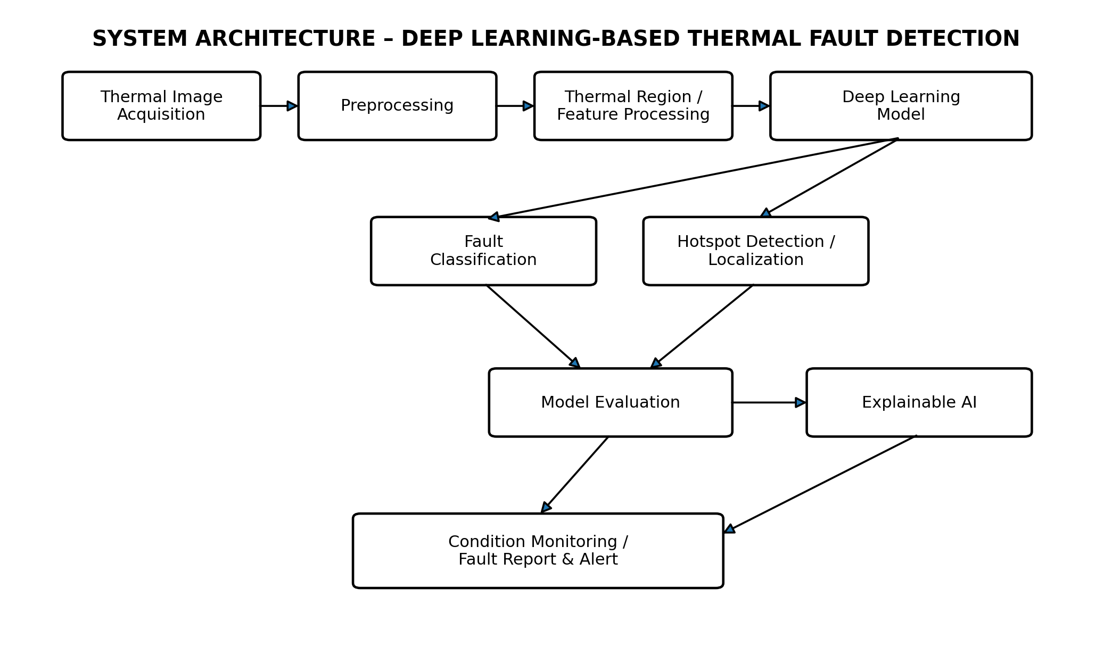
Figure 1. Proposed system architecture for deep learning-based thermal fault detection.

3. Modules and Their Functions
Module 1 – Thermal Image Acquisition
Purpose: Collect or receive infrared/thermal images of electrical or industrial equipment under normal and faulty operating conditions.
Main tasks:
• Acquire thermal images from a thermal camera or a suitable dataset.
• Maintain examples representing normal and different fault conditions.
• Store image data together with relevant class/condition information when available.
Output: Raw thermal images for further processing.
Module 2 – Image Preprocessing
Purpose: Prepare raw thermal images so that the deep learning model receives consistent and useful input.
Main tasks:
• Resize images to the model's required input size.
• Normalize image values.
• Reduce noise when necessary.
• Enhance thermal-image contrast.
• Perform basic thermal-region extraction where appropriate.
Output: Cleaned and standardized thermal images.
Module 3 – Thermal Region / Feature Processing
Purpose: Represent the thermal and spatial information needed for fault analysis.
Main tasks:
• Preserve important temperature-distribution patterns.
• Identify or emphasize relevant thermal regions.
• Prepare image features for deep learning without depending entirely on manually designed features.
Output: Model-ready thermal information/features.
Module 4 – Deep Learning Model
Purpose: Automatically learn patterns that distinguish normal and faulty thermal conditions.
Main tasks:
• Train a CNN or a suitable transfer-learning model.
• Learn spatial and thermal patterns from training images.
• Use data augmentation and appropriate training strategies to improve generalization.
Output: A trained model capable of making predictions on unseen thermal images.
Module 5 – Fault Classification
Purpose: Determine whether the equipment condition is normal or belongs to one of the defined fault categories.
Main tasks:
• Predict the class of an input thermal image.
• Produce the corresponding classification result/confidence where supported.
Output: Normal/fault category prediction.
Module 6 – Hotspot Detection and Localization
Purpose: Identify where an abnormal thermal pattern occurs within the image.
Main tasks:
• Detect abnormal hot regions.
• Optionally use object detection or image segmentation techniques.
• Mark or localize the region associated with a potential fault.
Output: Localized hotspot/abnormal region.
Module 7 – Model Evaluation
Purpose: Measure how reliably the trained model detects faults.
Main tasks:
• Calculate accuracy, precision, recall, and F1-score.
• Generate and analyze the confusion matrix.
• Compare performance across normal and fault categories.
Output: Quantitative model-performance results.
Module 8 – Explainable AI
Purpose: Provide an interpretable indication of which thermal regions influenced the model's prediction.
Main tasks:
• Visualize important image regions contributing to a prediction.
• Help users understand why the model classified an image as normal or faulty.
• Support analysis of model behavior during testing.
Output: Visual explanation/importance map associated with the prediction.
Module 9 – Condition Monitoring and Fault Report
Purpose: Present the model's output in a form useful for equipment monitoring.
Main tasks:
• Display the predicted condition.
• Show abnormal-region localization when available.
• Present evaluation or diagnostic information to the user.
• Provide a foundation for future real-time monitoring and predictive-maintenance integration.
Output: Interpretable thermal condition/fault report.

4. Overall Data Flow
The overall flow is: Thermal Image Acquisition → Preprocessing → Thermal Region/Feature Processing → Deep Learning Model → Fault Classification and/or Hotspot Localization → Model Evaluation and Explainable AI → Condition Monitoring/Fault Report. During model development, the training data are processed and used to learn the relationship between thermal patterns and equipment conditions. During operation, a new thermal image follows the same preprocessing pipeline and is passed to the trained model to obtain a fault prediction. If localization is incorporated, the system additionally identifies the abnormal region responsible for the detected condition.

5. Expected System Output
For each input thermal image, the system is expected to provide a classification of the equipment condition and, where the localization component is implemented, the location of the abnormal thermal region. The system should also support quantitative evaluation using standard classification metrics. The architecture leaves room for later integration with real-time thermal monitoring and predictive maintenance systems.

